Demonstrative Lesson
Form: 6
Teacher: Degtyareva M.S.
Date: 27.02.2014
Expert observer: Deputy Director for academic Affairs Tsarakova A.A.
Topic- Food
The lesson covers pronunciation of topical words more clearly and confidently as well as the structures Would like… . Would like ….? Wouldn’t like … . What would … like? It gives the students more practice to produce simple sentences and roleplay the conversation. The topical Food Song and visual aids are supposed to motivate the students to be interactive.

Object and Objectives: students are to be able to:
communicate in English using topical words (Food)
make up sentences with the structure Would like…/Wouldn’t like… .
make up sentences with the structure Would like…/Wouldn’t like… ?
make up sentences with the structure What Would like…/What Wouldn’t like… ?
make up a menu : Starters, Main Courses, Desserts
order a meal: What would you like?/I would like? Would you like? /yes, please/No, thanks.

Resources used: 1. Students’ website: www.learning chocolate.com category food
2. Students’ website: www.dreamenglish.com
3. Photocopiable Song activity+ CDwww.dreamenglish.com

4. Photocopiable communicative activity+CD
www. oup.com/elt/englishfile/elementary

Working forms: 1. individual
2. in pairs
3. in groups

Lesson Planning
- Warming up: Students are to focus on the pictures, listen to the speaker and repeat after the speaker. www.learning chocolate.com category Food_{y4;} Fast food; Drinks(vocabulary revision)
FOOD _{y4 -} 1.fish,2.meat,3.a sandwich,4. chicken, 5. cheese, 6. coffee, 7. ham, 8.salad, 9.a candy bar, 10.an egg, 11. a cookie, 10.milk
FAST FOOD - 1. hamburger, 2. cheeseburger, 3. hot dog, 4. pizza, 5. French fries, 6. roast beef, 7. doughnut, 8. Milkshake
Drinks - 1. coffee, 2. fruit juice, 3. hot chocolate, 4. soda, 5. milk, 6. tea, 7.water (3 minutes)

- Complete the sentences. Students are to focus on the sentences and change the pictures with the words orally.(vocabulary revision) (3 minutes)

I would like some 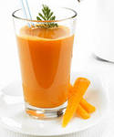

I would like an 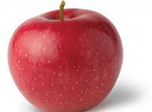

I would like some 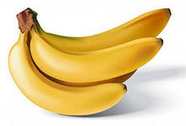

I would like some 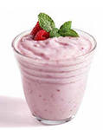

I would like a 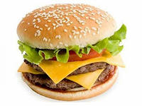

I would like some 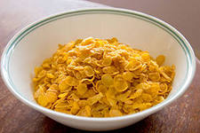

I would like an 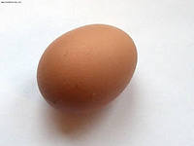

I would like some 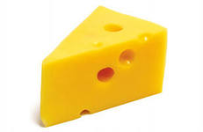

I would like some 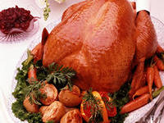

- Which is odd? Students are to cross out the odd word.(vocabulary revision) (2-3 minutes)
ham, water, tea, coffee, juice;
chocolate, jelly, cake, butter, sweet, jam;
banana, apple, jam, cherry, orange, berry;
hamburger, cheeseburger, tea, crisps, hot dog;
sweet, cake, soup, jelly, chocolate, jam;
- Listening: What is he/she eating? – Students are to listen to the speakers and choose the correct picture. (3-4 minutes) www.123listening.com.
salad, French fries, cheeseburger, fish, sandwich, corndog, spaghetti, chicken, steak, rice

- Guess: What is he/she eating? – Pantomime. Some students are playing/showing what they are eating, the other students guess. The activities are given on the cards.(3-4 minutes)

You are eating a banana.
You are drinking tea.
You are eating an orange.
You are drinking mineral water.
You are eating spaghetti.
You are eating soup.
You are eating an apple.

- Giving short answers to the question- Would you like …? – Yes, please./No, thank you.
The teacher points to the thing and asks the question. (3 minutes)

Would you like some jelly?- Yes, please./No, thanks.
Would you like some butter?- Yes, please./No, thanks.
Would you like a salad?- Yes, please./No, thanks.
Would you like some spaghetti?- Yes, please./No, thanks.
Would you like an egg?- Yes, please./No, thanks.
Would you like some milk?- Yes, please./No, thanks.
Would you like some fish?- Yes, please./No, thanks.
Would you like some berries?- Yes, please./No, thanks.
Would you like some chicken?- Yes, please./No, thanks.
Would you like a cake?- Yes, please./No, thanks.
- Relaxation – Food Song www.dreamenglish.com (2 minutes)
Lyrics: I Am Hungry Song
I'm hungry!
Do you like bread? Yes, I do!
Do you like cheese? No, I don't!
Do you like cookies? Yes, I do!
Do you like eggs? No, I don't!
I'm hungry (repeat)
Do you like fruit? Yes, I do!
Do you like ham? No, I don't!
Do you like vegetables? Yes, I do!
Do you like juice? No, I don't!
I'm hungry (repeat)
Do you like milk? Yes, I do!
Do you like tuna? No, I don't!
Do you like water? Yes, I do!
Do you like soda? No, I don't!
I'm hungry (repeat)
Let's go get something to eat!

- Playing flashcards (food) - Would you like …? – Yes, please./No, thank you. The students are to play the cards in pair. One of them offers the thing the other accepts or refuses. (3-4 minutes)

- Making up a menu (a restaurant/café). The students are to work in groups and present their projects. (10 minutes)
Starters
Main courses
Desserts
Price

Extra exercise. (2 minutes)
- Role playing –Ordering a meal. The students are to make up a conversation between the waiter and the clients using - What would you like? /Would you like …? – Yes, please. /No, thank you.
- Home work – making up a menu for (breakfast/launch/dinner)
- Results (2 minutes)

